Name | Arsh Raina
UID no. | 2021600053
Experiment No. | 4

AIM: | Apply the concept of recursion to solve a given problem.
Program 1
PROBLEM STATEMENT : | Write a recursive function to find the factorial of a number and test it.
ALGORITHM: | Step 1: Declare function factorial() takes integer as argument and returns integer.  Step 2: Inside main function, declare integer variable n and input it’s value. Call function factorial(n).  Step 4: Inside factorial(), if n is greater than or equal to 1, return product of n and function call factorial(n-1). Else, return 1.
PROGRAM: | #include<stdio.h>  int factorial(int n);  int main() {  int n;  printf("Enter a positive integer: ");  scanf("%d",&n);  printf("Factorial = %d\n", factorial(n));  return 0;  }  int factorial(int n) {  if (n>=1)  return n*factorial(n-1);  else  return 1;  }
RESULT:
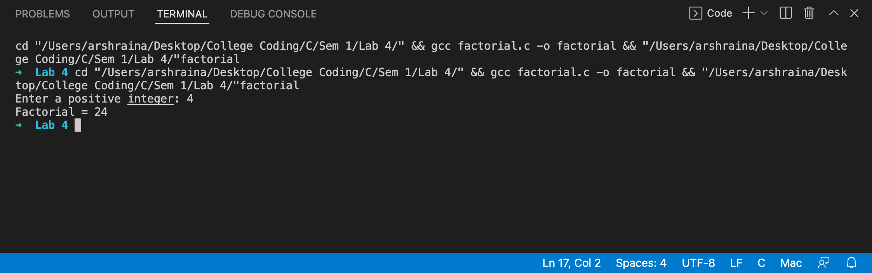
Program 2
PROBLEM STATEMENT : | Write a recursive function which returns the nth term of the fibonacci series. Call it from main() to find the 1st n numbers of the fibonacci series.
ALGORITHM: | Step 1: Declare function fibonacci() takes integer as argument and returns integer.  Step 2: Inside main function, declare integer variable n and input it’s value. Call function fibonacci(n).  Step 4: Inside fibonacci(), if n is less than 2, return n. Else, return fibonacci(n-1) +fibonacci(n-2).
PROGRAM: | #include<stdio.h>  int fibonacci(int n);  int main() {  int n;  printf("Value of n = ");  scanf("%d", &n);  printf("%d\n", fibonacci(n));  }  int fibonacci(int n) {  if (n < 2) {  return n;  }  return fibonacci(n-1) + fibonacci(n-2);  }
RESULT:
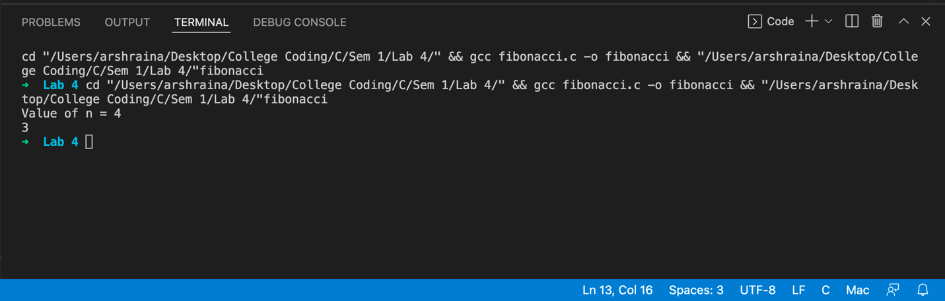
Program 3
PROBLEM STATEMENT: | Given a number n, print following a pattern without using any loop.  Example:  Input: n = 16  Output: 16, 11, 6, 1, -4, 1, 6, 11, 16  Input: n = 10  Output: 10, 5, 0, 5, 10
ALGORITHM: | Step 1: Declare function pattern() takes integer as argument and returns void.  Step 2: Declare integer varibel n.  Step 3: Inside main function, input the value of n. Call function pattern(n).  Step 4: Inside pattern(), if x is less than equal to 0, print x and return. Else, print x, call pattern(x-5) and print x in the given order.
PROGRAM: | #include <stdio.h>  void pattern(int x);  int n;  int main() {  printf("Enter a number");  scanf("%d", &n);  pattern(n);  return 0;  }  void pattern(int x) {  if (x <= 0) {  printf("%d ", x);  return;  }  printf("%d ", x);  pattern(x-5);  printf("%d ", x);  }
RESULT:
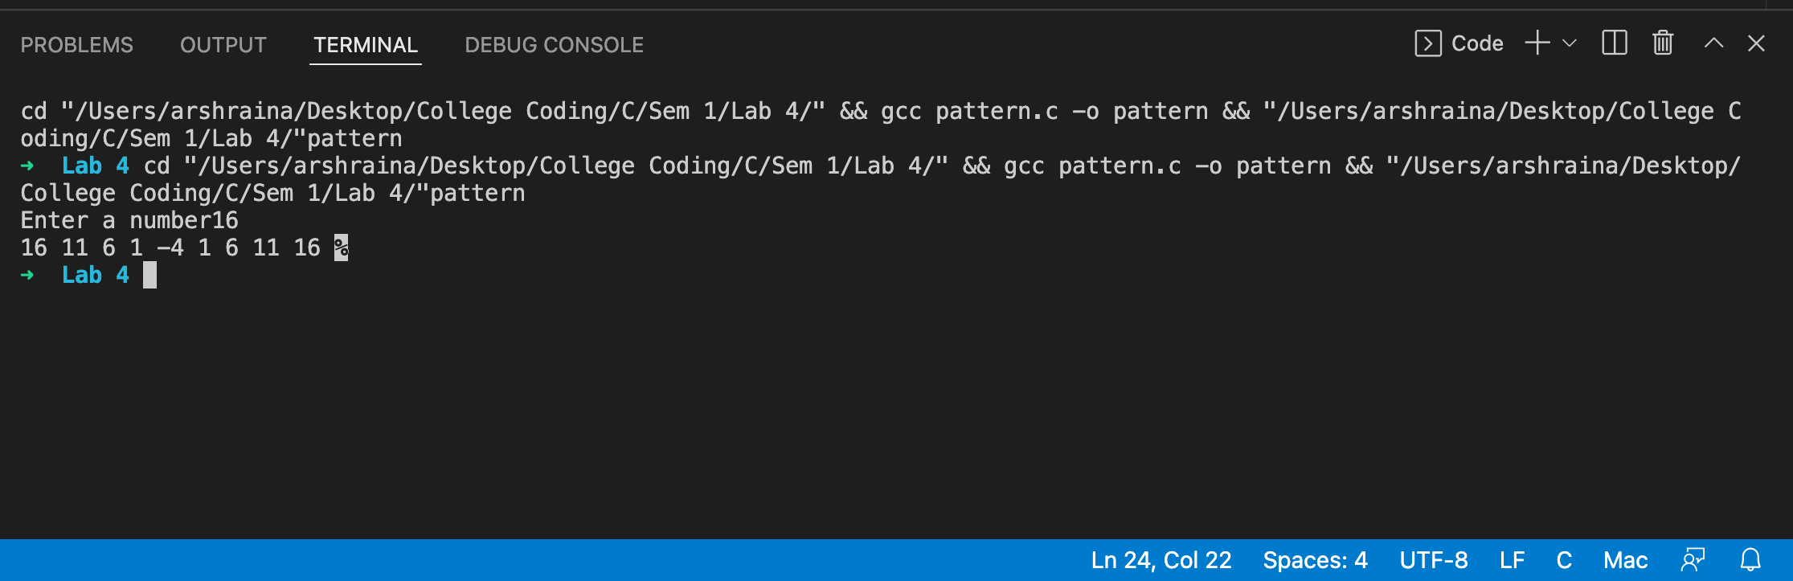
Program 4
PROBLEM STATEMENT:
  Ackerman’s function is defined by:
  A(m,n) =n+1 if m=0
  =A(m-1,1) if m≠0 and n=0
  =A(m-1, A(m,n-1)) if m≠0 and n≠0
  Write a function which given m and n returns A(m,n). Tabulate the values of A(m,n) for all
  m in the range 1 to 3 and all n in the range 1 to 10. A(1,1),......... a(3,10)
  m,n | m=1 | m=2 | m=3
  n=1 | Ack(1,1)= ans | Ack(2,1)
  n = 2
  n = 3
  …..
  n = 10
ALGORITHM: | Step 1: Define function ackerman(int m, int n).  Step 2: Inside main function, define integer variables m, n, a. While 1, run a for loop using variable m in range 1 to 3. Inside, run another for loop using variable n in range 1 to 6, to a assign value of ackerman(m,n). Print a.  Step 3: Inside ackerman(), if m equals 0 return n+1, else if m greater than 0 and n equals 0 return ackerman(m-1, 1), else if m greater than 0 and n greater than 0 return acckerman(m-1, ackerman(m,n-1)).
PROGRAM: | 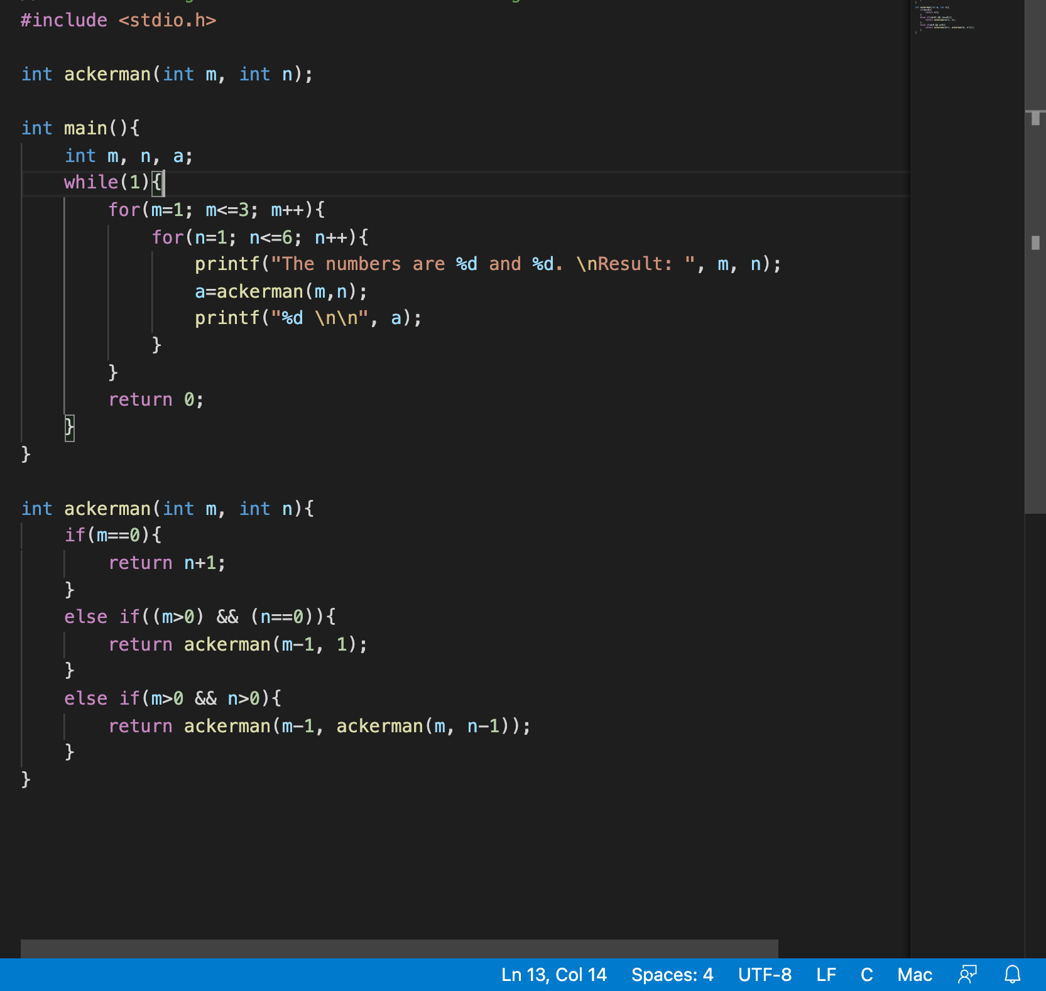
RESULT:
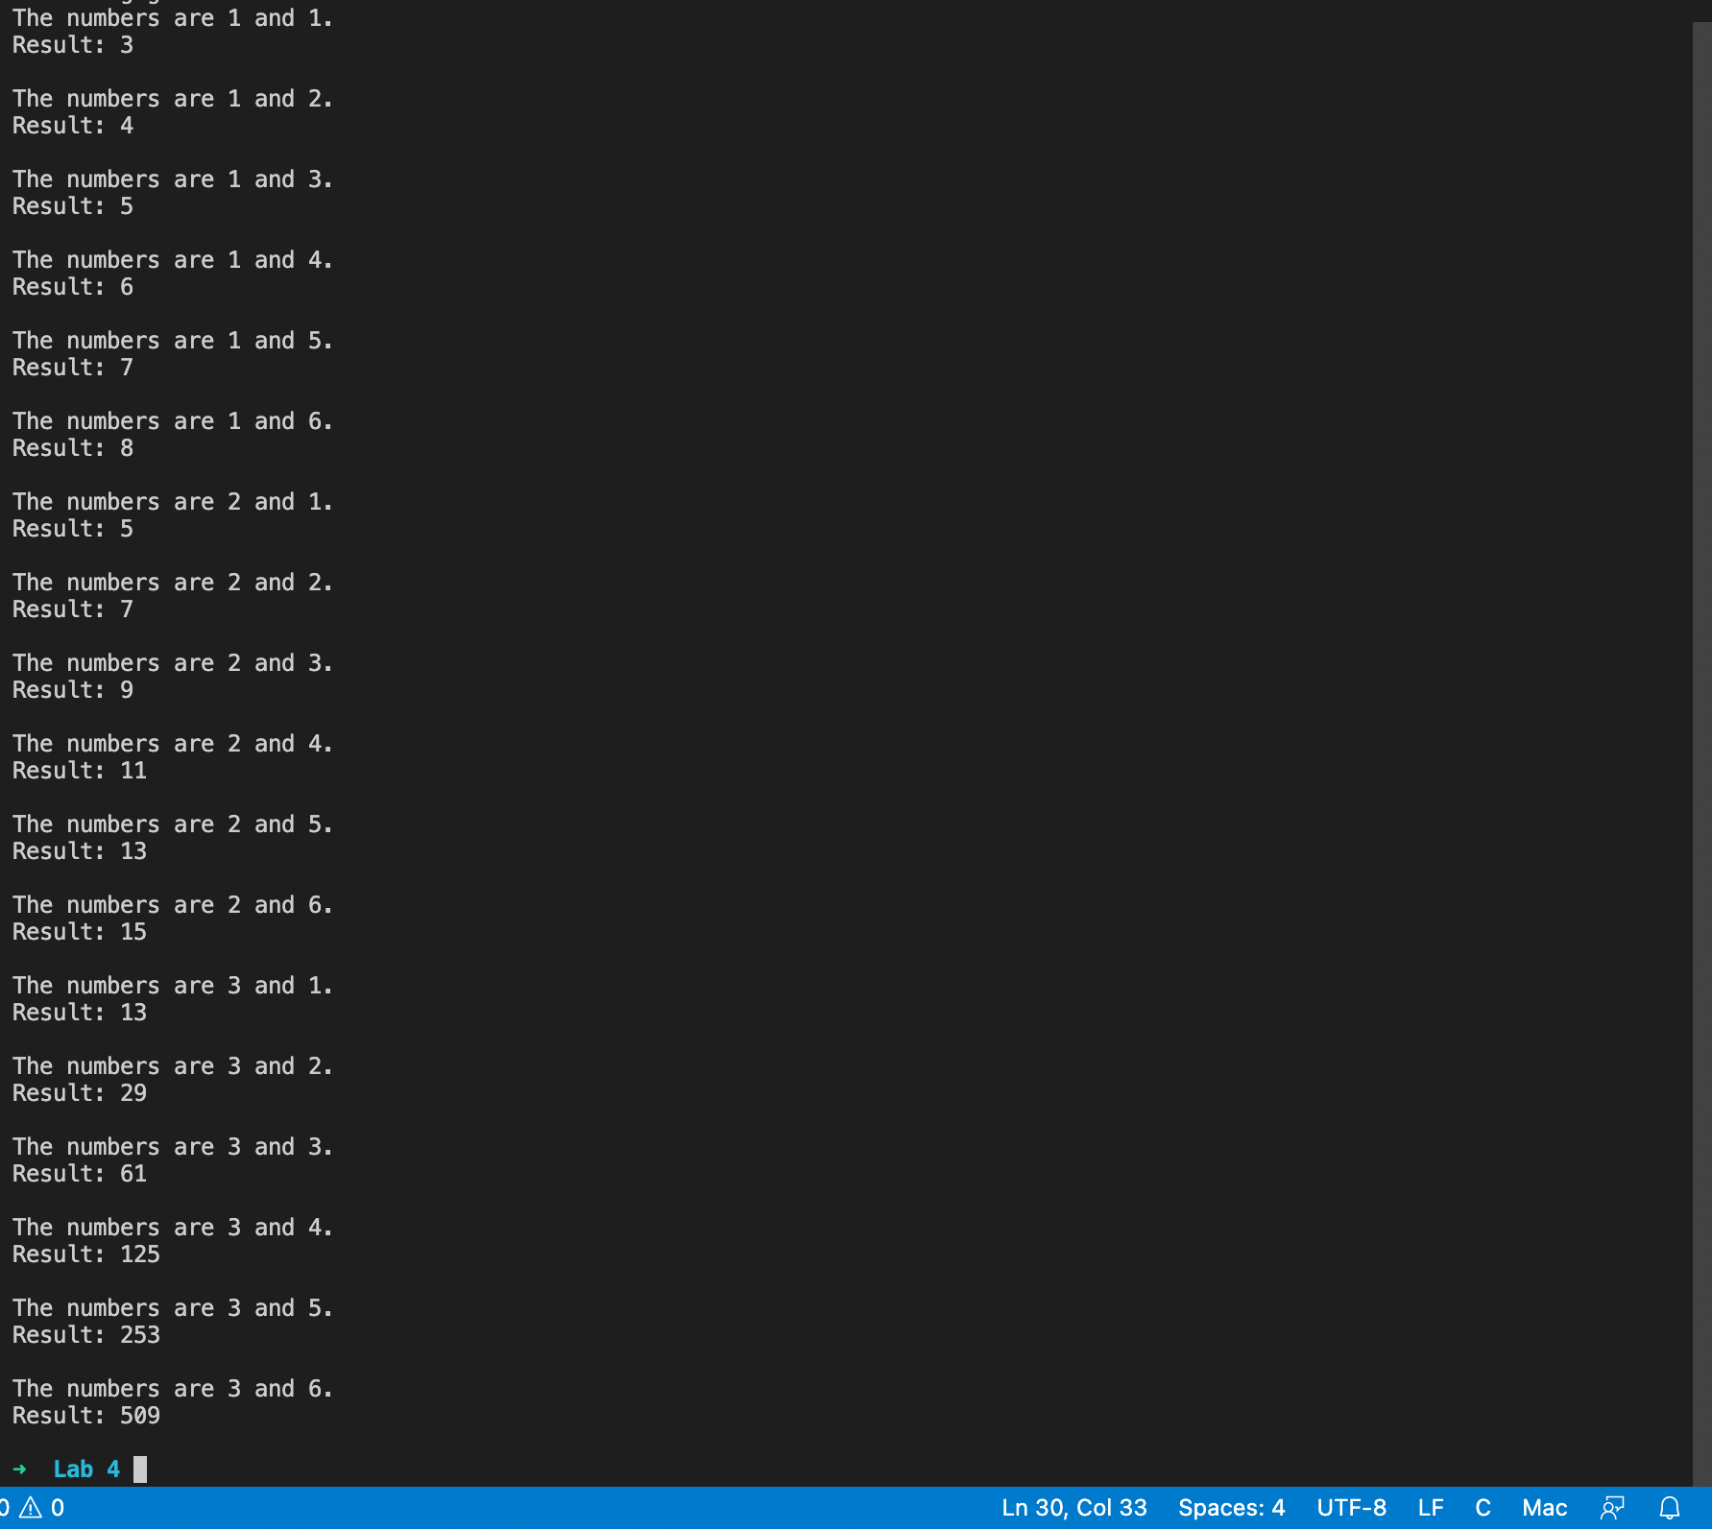
Program 5
PROBLEM STATEMENT: | Write a recursive function to return the minimum number of coins of given set of coin values that are required to produce a given amount. For example if you are given set of values {1,4,5}(indicating you had a supply of 1-cent,4-cent and 5-cent coins), and the amount 8, you should return 2, since the value 8 cents can be made with two 4-cent coins.
ALGORITHM: | Step 1: Declare integer variables a=0 , count = 1.  Step 2: Declare function coins(int n, int c) which returns integer. Inside, declare integer variables coin, temp. Run a while loop, inside input the value of coin, assign value of n-(n/coin)*coin to temp, increase the value of a by (n/coin), increase the count by 1, call function coins(temp,c). Exit the loop, return a.  Step 3: Inside main, declare variables n, dis. Input value of n and dis, print dis, print coins(n, dis)
PROGRAM: | 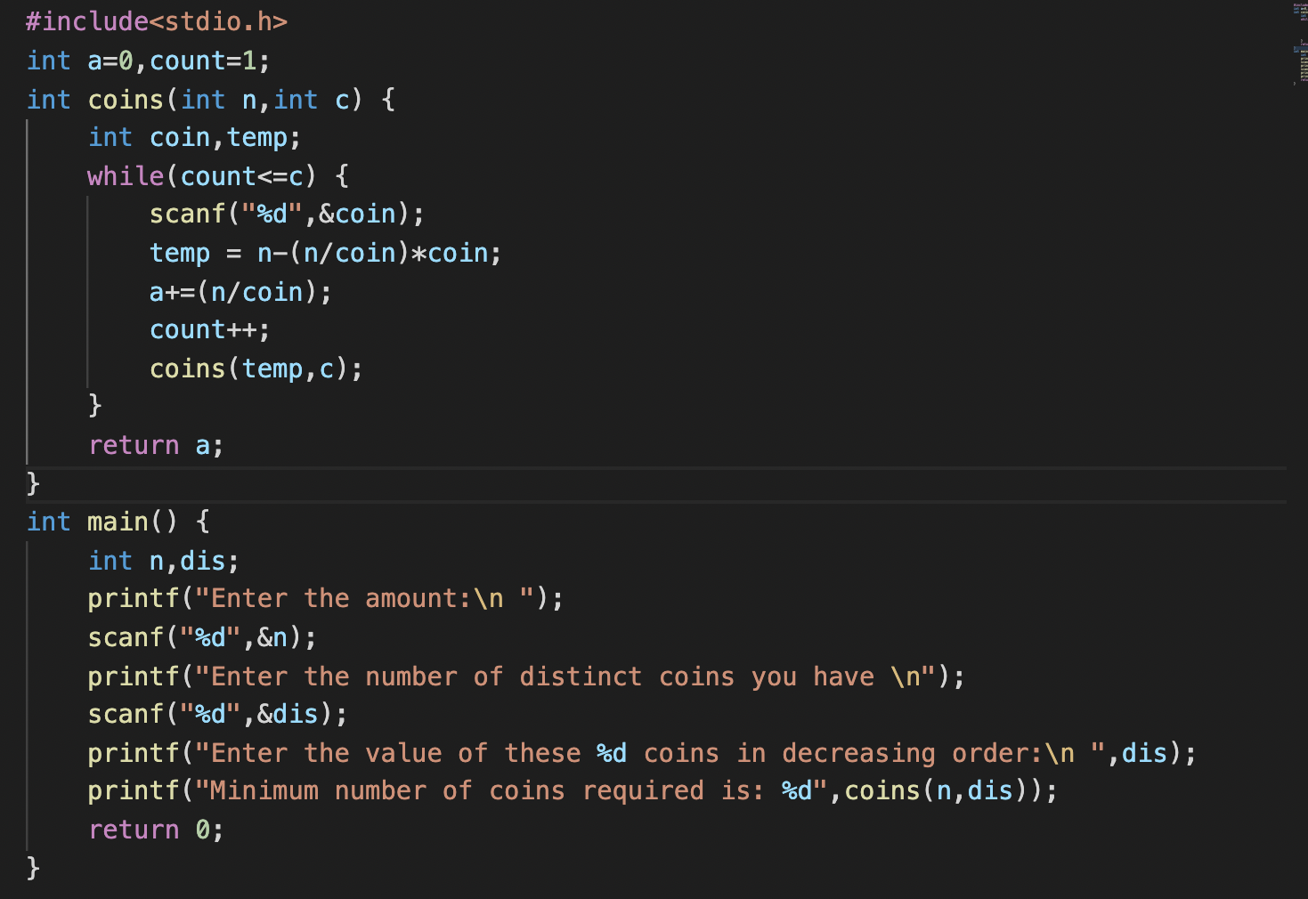
RESULT:
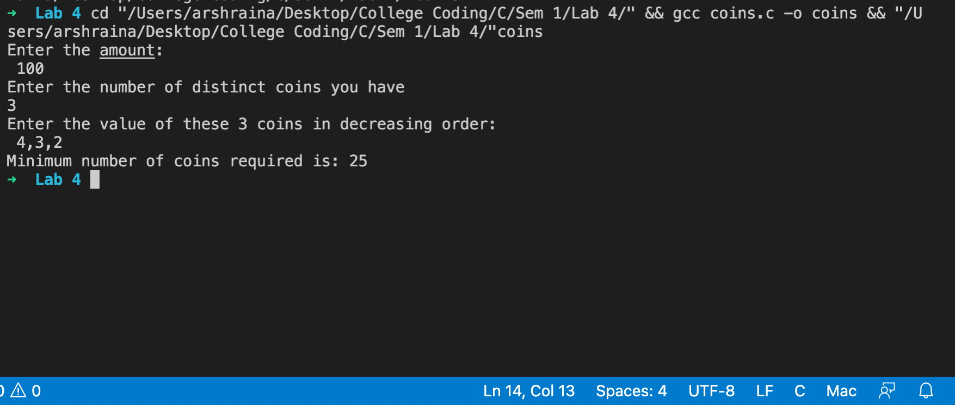
CONCLUSION: | Successfully applied the concepts of recursion to solve the given problems.
Ma’am I am sorry for the delay. I was travelling and thought that the submission was today at 11:59 PM.
- Arsh Raina

